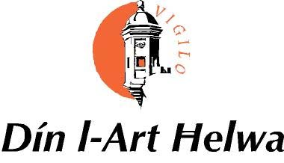

THE X DIN L-ART HELWA
ARCHITECTURAL HERITAGE AWARD 2014

Eligible projects include the restoration or conservation of buildings, the adaptation of buildings to new uses, building additions or alterations, or new building projects in conservation areas. The projects can relate either to a single building, a complex of buildings, or historic urban environment or townscape. The project will be judged on the quality of the work executed, its historic, cultural, educational and social relevance, the preliminary research conducted and the aesthetic and visual merit. The project may be on a scale ranging from small to large, and should display a standard of work which would be outstanding in a Maltese context.

Name of Project.................................................................

Registration No......................

The Project is entered for the following category:
(Please delete as appropriate)

A. Major Regeneration Project…..

B. Rehabilitation and Re-use of a Building……

C. Restoration and Conservation Project…….

Give a short description of the project and the qualities which make it outstanding and significant:

Completion date of project.................................

What work, if any, is still needed to complete the project?

NOT TO BE FILLED IN BY THE APPLICANT

Please comment on the following aspects of the project and rate them between 1(low) and 5 (high)
1. State of conservation of the building before project was carried out Rating...........

2. Thoroughness of research carried out archives, archaeology, stylistic parallels etc) Rating........

3. Handling of initial state of the building(s), functional issues and difficulties encountered Rating........

4. Response to the urban or landscape context and/or contribution to its environment Rating.........

5. Aesthetic and visual merit. Rating.......

6. Exterior conservation work quality (fabric, insertions, materials, structure, legibility,
reversibility) Rating…..

7. Interior conservation work quality ( finishes, insertions, materials, structure, legibility,
reversibility) Rating .......

8. Quality of new work (design, materials, decorations, landscaping) Rating.......

9. Historical, cultural, educational and/or social value. Rating......

10. Project management and planning arrangements. Rating......

11. Overall assessment with respect to its quality and its contribution to Maltese cultural
heritage. Rating.......

NOT TO BE FILLED IN BY APPLICANT

On this single page, please elaborate on the previous points and add anything you think relevant to the judging of the project. Please give your opinion regarding the project`s qualities, weaknesses and its importance to Maltese cultural heritage. Please state the qualities that make it outstanding and significant in a Maltese context.

